Zeta distribution

Def

Parameter



Support



PDF

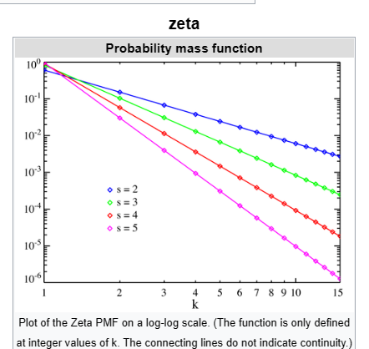



CDF

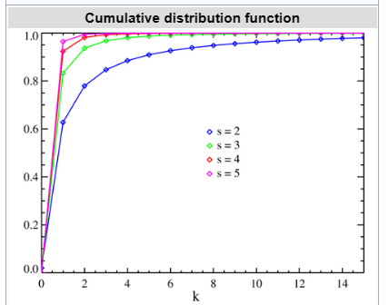



Expected Value



Variance



Mode



Entropy



MGF



CF



Moment

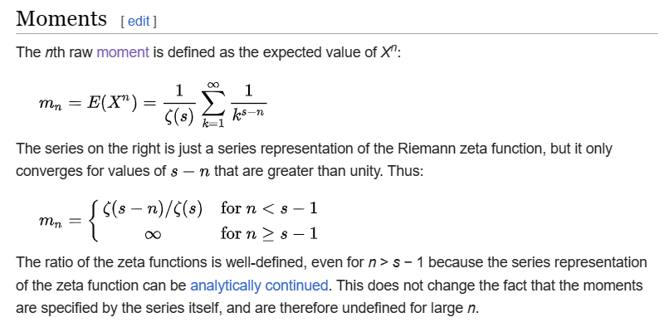

Ref

[Zeta distribution - Wikipedia](https://en.wikipedia.org/wiki/Zeta_distribution)